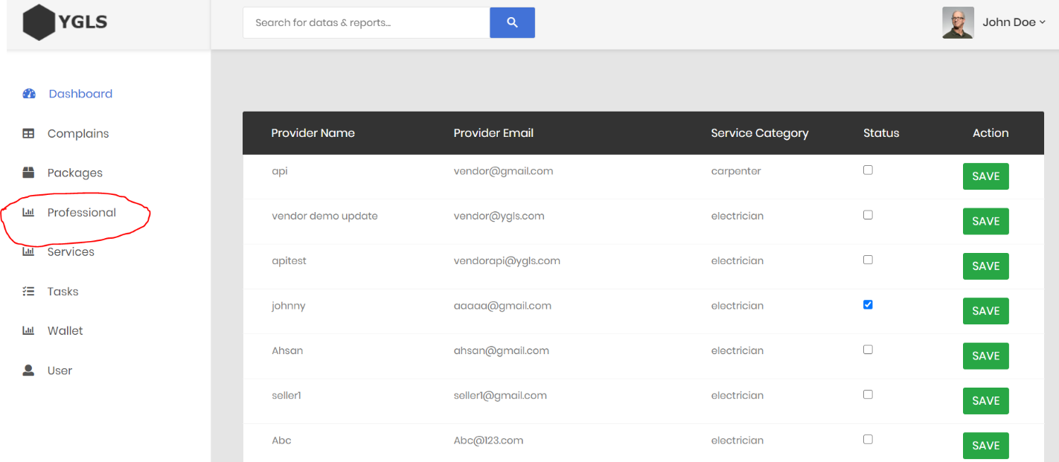Added a new menu item to manage professionals new registration. According to this new feature, admin can approve or reject the new registration by clicking the check box.

Into the vendor table, a new column has added ( status coiumn )

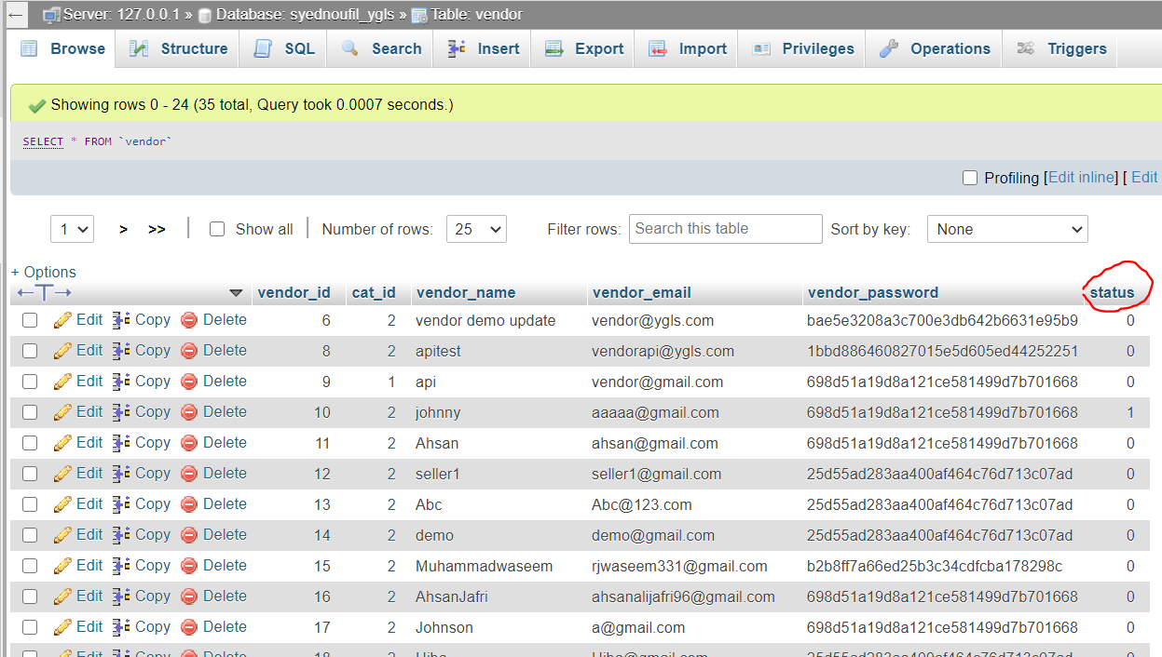

Status 1 means accepted account.

Note: I’m still working on the status update part.